43.9: a) For 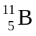the mass defect is:
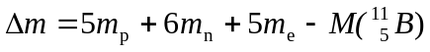
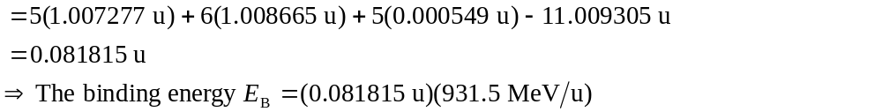
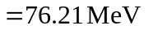
b) From Eq. (43.11): 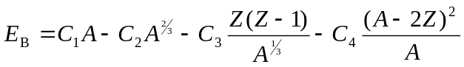and there is no fifth term since Z is odd and A is even.
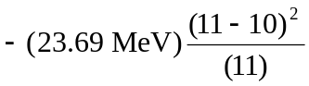
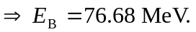
So the percentage difference is 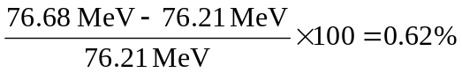
Eq. (43.11) has a greater percentage accuracy for 